**Section -0:**

1. mkdir project_dir

cd /c/Users/sonu/Desktop/Assi1/project_dir

1. $ git init
2. touch index.html
3. git status
4. git add .
5. git commit -m "first commit"
6. touch info.txt
7. git status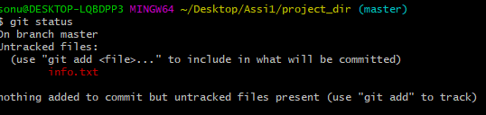
8. touch .gitignore
9. git status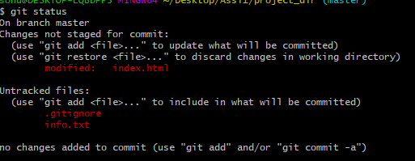
10. git add .

git commit -m "some changes"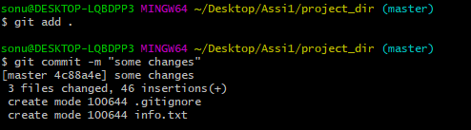

1. git log

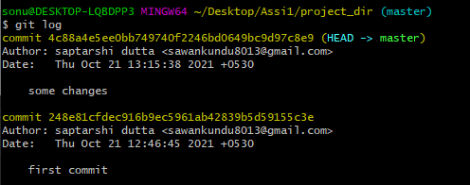

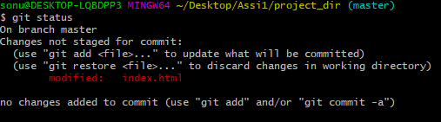

1. git checkout -- index.html



1. git add index.html
2. git revert 086aaccbcb9c4ec162d35899e5f41c9445117e27 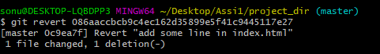
3. git config --global alias.my-add add
4. git my-add .

git commit -m "after renameing add to my-add"

1. git revert 0c9ea7f58a63b37594960c31c2034f80ea127899